TABLEU PROJECT

*Submitted by*

*SYED AMEER. S*

**Project Link:-**

<https://public.tableau.com/app/profile/syed.ameer5632/viz/CarInsuranceAnalysis-Project/Story1>

**EDUCATION DASHBOARD 1:-**

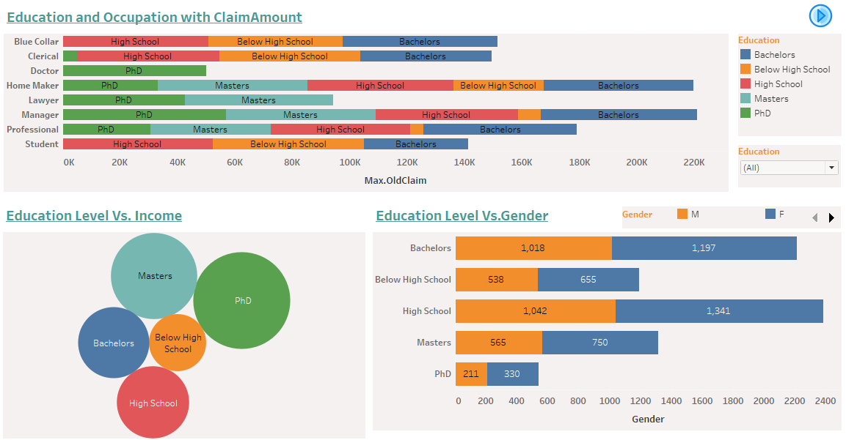

**1) In the occupation Doctor , the only peoples who completed the education in PhD.**

**2) All the education level peoples only obtained in the occupation Home Maker.**

**3) Moreover, the peoples who completed their education in Bachelors occurred in moreover occupations.**

**4) The peoples who have completed their education in PhD and occupation is Manager have reached the maximum old claim amount[57,037].**

**5) The peoples who have completed their education in PhD had got the high Income compare to others.**

**6) The female count is greater than male in all education levels.**

**EDUCATION DASHBOARD 2:-**

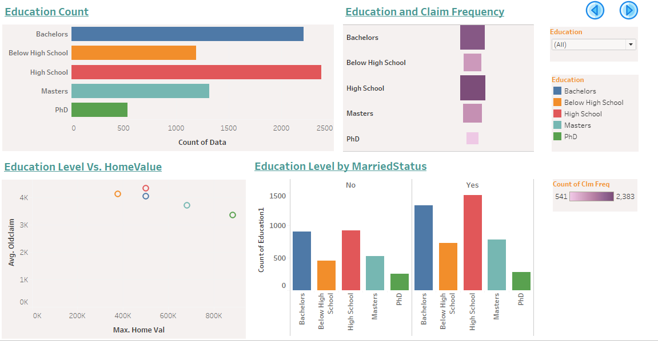

**1) The most of the peoples have completed their education level at High School level,secondly in Bachelors.**

**2) The peoples who have completed their education in PhD had the highest Home Value[8,85,282] with average old claim amount 3,348.6.**

**3) The maximum number of claims obtained in education level High School[2,383] and Bachelors[2,215].**

**4) The minimum number of claims obtained in education level PhD[541].**

**OCCUPATION DASHBOARD:-**

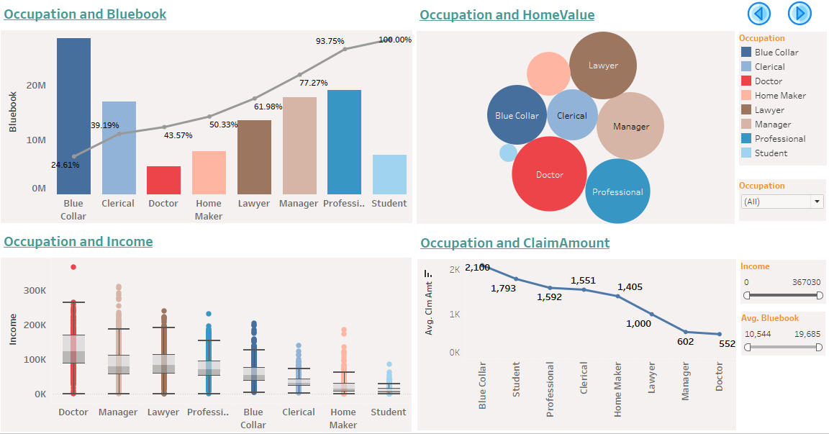

**1) The peoples who have occupation in bluecollor having the car worth higher and also the peoples who have occupation in students having the car worth lower.**

**2) The maximum of average home value is [250,422] in the occupation Doctor and the minimum of average home value is [14,268] in the occupation Student.**

**3) The maximum of average claim amount is [2,100] in the occupation Bluecollor and the minimum of average claim amount is [552] in the occupation Doctor.**

**4) The peoples who have occupation in the Doctor had the max income compare to other occupations.**

**GENDER DASHBOARD:-**

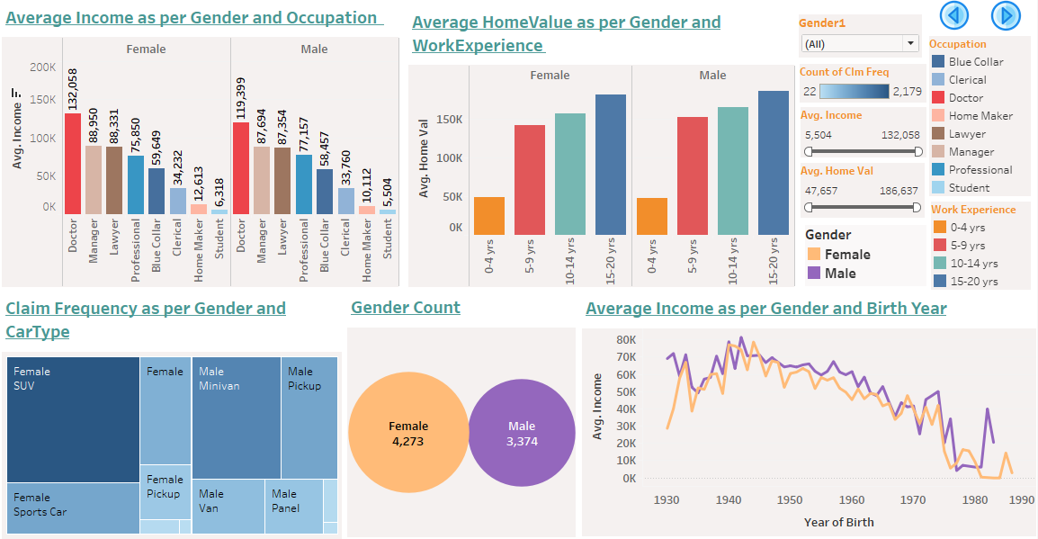

**1) In the Female gender , got the high average of income[132,058] in the occupation doctor and got the low average of income[6,318] in the occupation student.**

**2) In the male gender , got the high average of income[119,399] in the occupation doctor and got the low average of income[5,504] in the occupation student.**

**3) In the Both Genders , have the high average of homevalue with experience 15 to 20 years, similarly the low average of homevalue obtained in the experience level 0 to 4years.**

**4) In the Female gender, who having the cartype SUV[2,179] are claimed maximum no of claims, and who having the cartype Van[77] and Paneltruck[22] are claimed minimum no of claims.**

**5) In the male gender, who having the cartype Minivan[1,407] are claimed maximum no of claims, and who having the cartype SUV[85] and Sportscar[23] are claimed minimum no of claims.**

**6) Generally, the female count is greater then male counts.**

**7) In the Female gender, the people who were born in 1944 had the high average of income[78,708].**

**8) In the male gender, the people who were born in 1942 had the high average of income[81,457].**

**CLAIMS DASHBOARD:-**

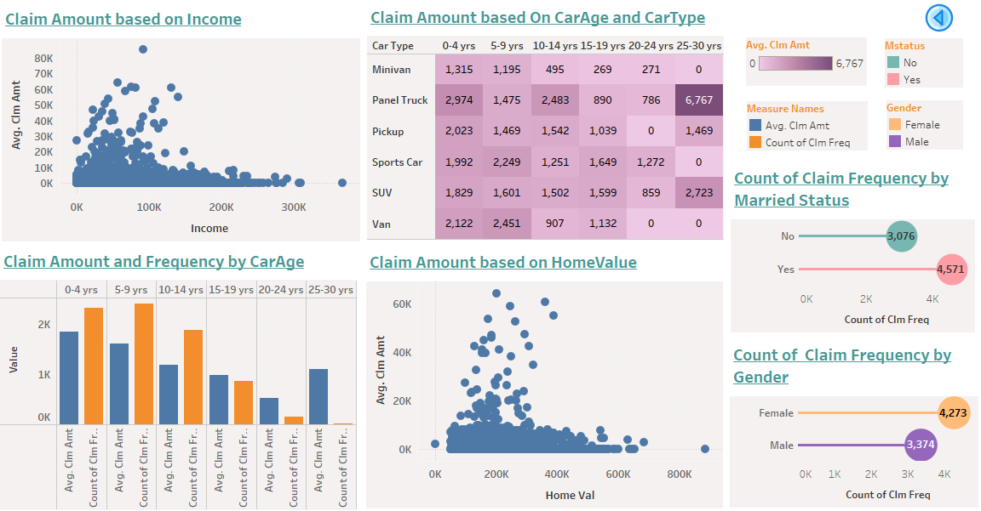

**1) The maximum average claim amount is [85,524] with the income [92,264].**

**2) The maximum average claim amount is claimed for the car age 0-4 years and also the minimum average claim amount is claimed for the car age 20-24years.**

**3) The maximum no of claims is claimed for the carage 0-4years and 0-9 years and also the minimum no of claims is claimed for the carage 25-30 years.**

**4) The maximum average claim amount is [64,182] with the Homevalue [201989].**

**5) The maximum average claim amount is claimed for the cartype paneltruck with the carage 25-30 years.**

**6) The minimum average claim amount is claimed for the cartypes minivan, pickup, sportscar, van with the carage 25-30 years, 20-24 years, 25-30 years, 20-24 years,25-30 years.**

**7) The maximum no of claims is claimed by peoples whose married.**

**8) The maximum no of claims is claimed by gender female.**

**CARS DASHBOARD:-**

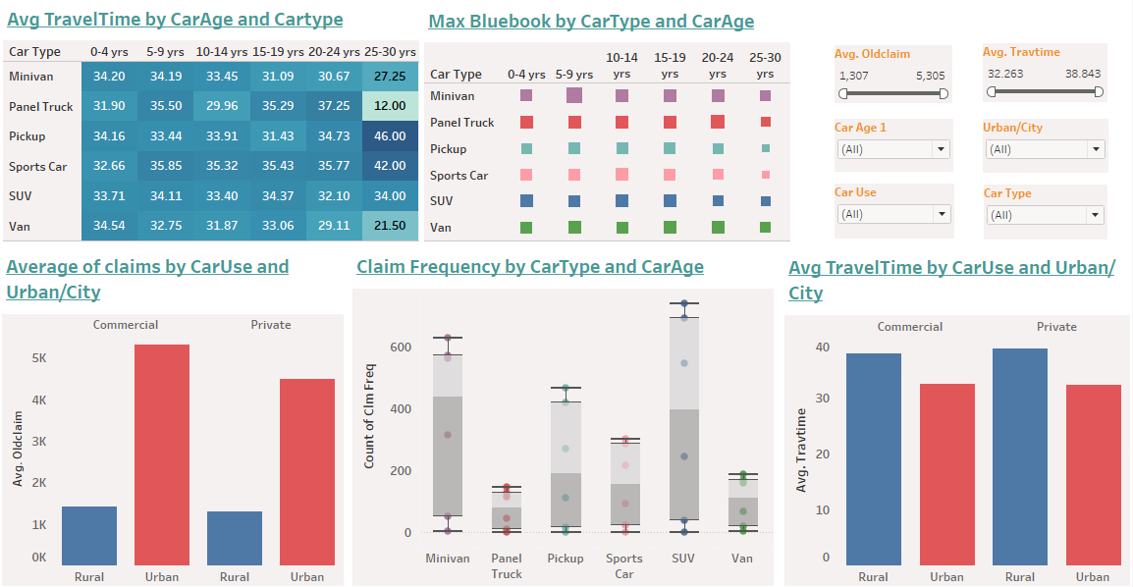

**1) The average of maximum traveltime is [46.00] for the cartype Pickup with the carage [25-20 years] and the average of minimum traveltime is [12.00] for the cartype Paneltruck with the carage as same [25-30] years.**

**2) The maximum of maximum worth of car is [65,879] for the cartype Minivan with the carage [5-9 years] and the minimum of maximum worth of car is [15,390 , 15,360] for the cartype pickup and sportscar respectivley with the car age [25-30 years].**

**3) The avearge of old claim amount is extremely high in urban area for both the commerical and and private caruse.**

**4) The maximum no of claims[740] is claimed for the cartype SUV and carage [5-9 years] and the minimum no of claims [1-4] is claimed for all the cartypes with the carage [25-30 years].**

**5) The average of traveltime is little bit higher in rural area compare to urban area for both the commercial and private caruse.**